Shabbos Stories for
Parshas Beshallach 5781
Volume 12, Issue 22 17 Shevet/January 30, 2021
Printed L’illuy nishmas Nechama bas R’ Noach, a”hs

For a free subscription, please forward your request to keren18@juno.com
Past stories can be found on the website ShabbosStories.com
Story #1203
The Final Word
From the desk of Yerachmiel Tilles
editor@ascentofsafed.com

It was with heavy hearts that a group of senior chasidim assembled in the home of their master, Rabbi Zvi-Elimelech of Dinov,the “Bnei Yissaschar”. Their rebbe had fallen ill, and it was understood that his moments were numbered. They joined his children and grandchildren to be with him in his closing hours of physical life, and perhaps hear some final instruction from their mentor and guide.

The rebbe’s eyes were closed, and a medley of awe and ecstasy played upon his holy face. “Our master is spending his last minutes in communion with his Maker,” they all thought; “how selfish of us to assume that he would have something to say to us at this time!”

The Rebbe Glanced on a Man Standing to One Side
Suddenly, the rebbe’s eyes opened and began to search the small crowd. Finally his glance rested on a man who was standing to one side. The chasidim made way for this man, and gently propelled him toward the rebbe’s bedside.
“Reb Shmuel,” the chasidim heard the rebbe inquire, “what is it that you wanted to ask?”
“Rebbe,” said the man, whom no one recalled ever having seen before, “the wool that I purchased . . . what shall I do?”
“ Don’t worry, Reb Shmuel,” said Rabbi Tzvi Elimelech. “Wait until next winter. The price will rise, and you will make a handsome profit.”
The rebbe’s eyes closed. Soon after, his soul departed to its heavenly abode.
In the days that followed, the chassidim hotly debated the significance of their rebbe’s final words. The mysterious “wool merchant” had disappeared as suddenly as he had appeared; certainly, he must be one of the thirty-six “hidden tzadikim,” or perhaps Elijah the Prophet? Various theories were offered on the Kabbalistic meanings of “wool,” “winter” and “handsome profit.”

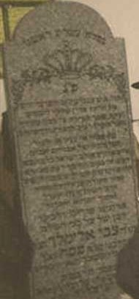
Matzava (tombstone of Rabbi Zvi-Elimelech of Dinov

Word of these deliberations reached the ears of Rabbi Tzvi Elimelech’s son, Rabbi Dovid. “You are mistaken,” he said. “There is no mystery here, no hidden meaning, only a profound expression of my saintly father’s love for every Jew.
Reb Shmuel is a simple merchant, who would often come to seek Father’s counsel and blessings regarding his business affairs. Recently he had bought a large quantity of wool, after which its price had dropped sharply; the poor man faced the loss of all his assets, as well as huge debts for the sums he had borrowed to make the purchase. He rushed to Dinov to seek my father’s advice.
Upon his arrival, he followed the crowd into Father’s room, unaware of why we had assembled. Father, although in his final moments, sensed the presence of a Jew in need and considered it his highest priority to assure him that all would be well.”
~~~~~~~~~~~~~~~~~~~
Source: Lightly edited by Yerachmiel Tilles from the excellent-as-always rendition of R. Yanki Tauber, originally prepared for Week in Review, an innovative Chabad publication in the 90’s, and now currently posted on chabad.org.
Biographical note: Rabbi Zvi-Elimelech Shapira of Dinov (1785 - 18 Teves, 1841) was the nephew of Rebbe Elimelech of Lizhensk and disciple of the "Seer" of Lublin and of Menachem Mendel of Rimanov, and a renowned Torah scholar and Chasidic master in his own right. He is best known for his scholarly and mystical work, Bnei Yissaschar, which includes a chapter for each month of the year.
Connection: Seasonal -- 18 Tevet (Shabbat, Jan. 2) is the 180th yahrzeit of Rabbi Zvi-Elimelech Shapira, the “Bnei Yissaschar.”

Reprinted from the Parashat Vayechi 5781 email of KabbalaOnline.org, a project of Ascent of Safed.

Putting Things into Perspective with the
Help of Great Grandpa
By David Bibi

I wrote a version of this for our company newsletter on Friday, but I thought the message was just as important for the Torah newsletter, so I am posting an edited and updated version to you.

A Family Tradition of Two Centuries
When you grow up in a family creating decorative arts for at least two centuries, the auction circuit is always a part of your life. While still in high school, Sotheby’s, Christies, and Phillips were my regular haunts. And before long establishing accounts across the country from Butterfields in San Francisco to Ames in LA to sell pieces was my pre-eBay world. I was a partner in a large gallery in Palm Desert and had my auctioneer’s license before I was twenty. Ronald Reagan getting elected was probably our biggest coup as once he placed that Remington Bronze on his desk, I put the family foundries to work recasting Western pieces and shipping them throughout the world.

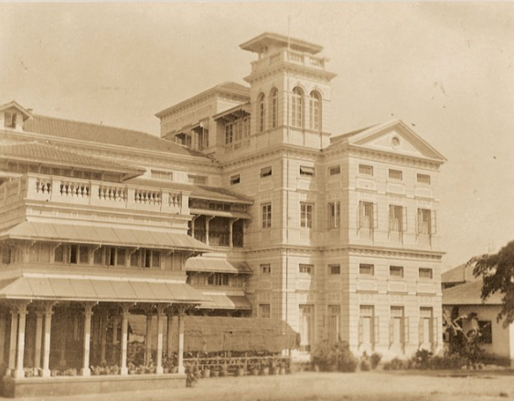
The legendary Sassoon mansion in Bombay, India – the Il Palazzo

This week we watched the auction at Sotheby’s with interest, titled, SASSOON: A Golden Legacy, a further group of rare and important Judaica from the family collection of the fabled “Rothschilds of the East.”
The silver pieces, manuscripts, and textiles that feature here were assembled over the course of more than a century, and range geographically from Western Europe to the Far East and chronologically from the eleventh to the twentieth centuries.
A Renowed Artisan from His Youth
My great grandfather Joseph Ovadia Bibi was a renowned artisan from his youth. He was a master of hand chasing on silver, brass and other metals. It’s a technique of detailing the surface of a sterling or other metal article with various hammer-struck punches. Many of us may have never heard the term, but it’s the technique used on many of the silver Torah cases in our synagogues, especially the older ones.

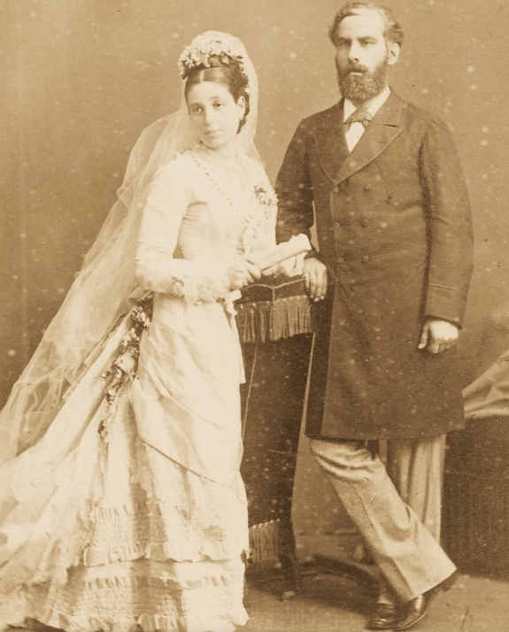
Solomon and Flora Sassoon

Sent to India, Asia and Great
Britain by the Sassoon Family
The Sassoon family hired Joseph for a period of five years sending him to India, Asia and Great Britain to restore and create pieces for them. Our grandfather Reuben and his brothers David and Morris, related stories to us of their father’s days in Bombay and how he lived with Solomon (1841-1894) and Flora Sassoon (1859-1936) at their residence there called Il Palazzo – see image above.

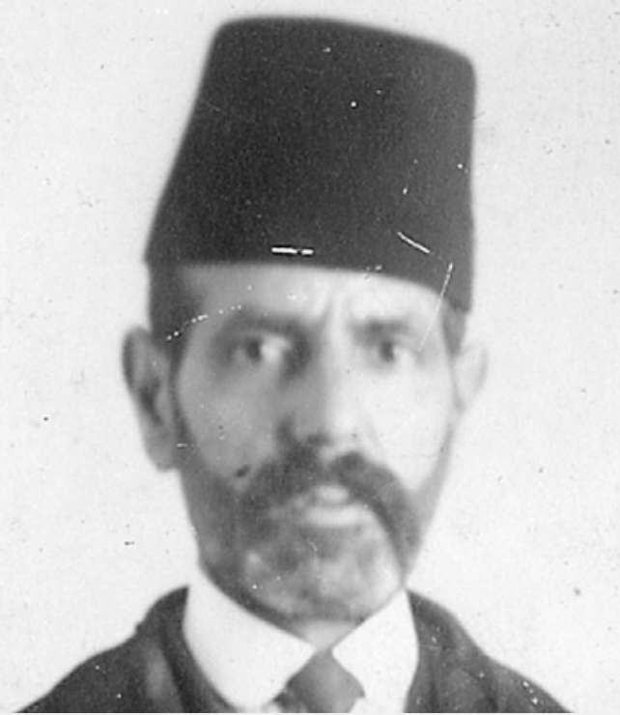
Joseph Ovadia Bibi

(Later on, our great grandfather traveled the world teaching his method from Damascus in the near East, down to Northern Africa, West to France and finally to San Francisco in the Americas before settling in New York with his arriving family. (many of the stories of his life and the family’s early days in America can be found in the opening chapters of Artscroll’s book Nouri.)
Our grandfather Reuben shared his father’s gift as did my own father Joseph. I would say of my father, that one could give him a piece of metal or a block of wood and he could create a work of art. We all remember of the large work bench in the furniture factory on McDonald Avenue that was filled with Judaica items sent from the synagogues for my dad to repair. He was sent Torah cases, Eliyahu chairs, rimonim, and seniyah trays of Eliyahu Hanavi.

Transforming a Box of Junk
Into a Beautiful Chandelier
My dad would tell of his own father who left medical school in American University in Beirut in 1911 to join his dad on his journeys in the early twentieth century, that he could take a box of junk and create a beautiful chandelier almost miraculously. During the depression, they would visit junk yards, use coke bottles, metal spare parts and magically create beautiful fixtures.
Alas, the gift of Ovadia, of Yosef, of Reuben and my dad skipped me. I can’t even draw!
Looking through the Sotheby’s catalogue, I wondered which of these pieces my great grandfather’s hands touched? Which did he repair, restore or actually fabricate for them? There is so much history in the pieces. And so many are of his work.
Unfortunately for me, but fortunately for them, many of the items sold for far more than the initial estimates so all my bids went with the wind. Still, looking through the catalog online and reviewing each of the pieces took me back.
In the days when I traveled two hundred days each year and sometimes might complain about a delayed plane, a terrible hotel room, or driving through a foreign country where the road signs were barely legible in the midnight rain, I would imagine myself in his shoes.
Weeks of travel required to get to a temporary destination via ocean liner, train and sometimes mule and camel. Sleeping in tents or cities with no running water and never a complaint. Years without seeing or even getting a letter from family while we have Facetime from anywhere in the world effortlessly seeing and speaking with each other. Thinking about him and his life helps to put things in perspective. What we complain about would have been unimaginable miracles to him.

Comparing Today’s COVID with the Spanish Flu
My doctor friends started receiving their covid vaccines this week. At the same time, I am hearing from a number of health care professionals that for whatever reason, the current strain is much more contagious. The doctor who tested me after returning from Florida told me that wives who never caught it while their husbands were sick are suddenly getting it from out of the blue. And then we have the new strain from the UK to deal with. We are hoping the vaccine will be as effective as promised. Perhaps its darkest before the dawn.
But let’s try to imagine our great grandparents and grandparents in 1918 and 1919. The devastating war was ending in Europe and suddenly they were hit with the Spanish flu which infected a third of the world’s population and eventually took 50 million lives and tragically so many children.
I listened to a zoom talk featuring Dr. Victor Grazi and doctors from Mount Sinai this week, and with Hashem’s help we have learned so much and have a full repertoire of dealing with Covid today that we didn’t have in the nightmarish days of March and April.

A Lesson from Our Ancestors in Egypt
This week, we read of Jacob and his family coming down to Egypt; a visit that would last 210 years and result in terrible slavery and oppression to culminate in the Exodus which we will read about over the next six weeks. When we complain, we need to stand in the shoes of those in Egypt.
Our extended family, his hundreds of descendants ( most likely more) are grateful of the legacy of Joseph Ovadia Bibi and although we never knew him, his image is in all of our offices and through the stories of his life, both published and passed down, and with that we are so lucky to maintain the link, the chain and the amazing connection to the past.

Reprinted from the Parshat Vayigash 5781 email of Shabbat Shalom from Cyberspace.

Deaf Angels and Failed Dates
By Elchonon Isaacs

Rabbi Levi Yitzchak of Berditchev (1740–1809) is one of the most beloved Chassidic leaders, renowned for his compassion for every person. In 1785, R. Levi Yitzchak arrived in Berditchev, where he led the community for nearly 25 years, until his passing. There are many stories about his love and advocacy for Jews, no matter their spiritual state. Our story is a personal one, about his own life.
When his children were of age to be married, R. Levi Yitzchak hired a matchmaker to suggest potential suitors for them. R. Levi Yitzchak would give a pitak (a five-kopek coin) for every suggestion, even if nothing materialized from the suggestion.
With all the responsibilities of a town rabbi, R. Levi Yitzchak was a busy man. In addition, he was known for his tremendous excitement to serve G-d, and his intense ardor often caused him to act without consideration for his surroundings.
Certain portions of prayer would send him into a state of such rapture, it was not unusual to see him jumping on the tables. This made it difficult for the matchmaker to secure an appointment with the rabbi.
The matchmaker figured that while R. Levi Yitzchak was folding his tallit and tefillin after prayers would be an excellent time to suggest his ideas. The appointment was not fixed, and at times the matchmaker had to wait until R. Levi Yitzchak was ready. One day, he offered several suggestions and received his compensation. None materialized, however, and, feeling disheartened, he stopped bringing ideas to the rabbi.
Some time passed and R. Levi Yitzchak summoned the matchmaker. “Why did you stop coming?” he asked. “The suggestions themselves play an important role in setting up a Jewish home. Moreover, part of the great mitzvah of ahavat Yisrael is to take an interest in the welfare of a fellow Jew, specifically if you will be able to earn a livelihood by doing so.”
The matchmaker replied with his own question, “What is the point of making suggestions if they do not pan out anyway?”
R. Levi Yitzchak explained, “Our sages taught, ‘Forty days before a baby is formed, a heavenly voice announces who this person will marry.’¹ Each Divine announcement gives vitality to the angels, and the angels repeat what they have heard.
“When a person studies Torah and does mitzvot, it creates angels above. But if a person does not have the proper intentions and enthusiasm, the angels born of his actions have defects—some are blind, and others are deaf, etc.
“So when the announcement is made regarding who will marry, these impaired angels do not hear correctly, and they conflate the names. When an angel speaks, it has an impact, and the person does not reach their intended match until all the names of those impaired angels have been suggested. Only after all the suggestions have been brought up and do not pan out can the person meet his or her true soulmate.”
With this newfound insight, the matchmaker got back to work.
~~~
This story was related in a letter by R. Yechezkel Feigin, the Previous Rebbe’s secretary, to his dear friend Reb Mendel Cunin. Reb Mendel, one of the founding members of Chabad in America, immigrated to the US in 1927. The letter is from 1931.
From the letter, it is evident that Reb Mendel had asked for a blessing to find his soulmate. When the match did not materialize, he penned a letter to Reb Yechezkel sharing his frustration.
Reb Yechezkel responded:
I received your letter, and am sending you the crux of the Rebbe’s answer. Do not overthink the last episode, and in due time new ideas will come, and you should consider them. The Rebbe did not answer you himself because he is waiting for the engagement to be announced …
… I would be remiss if I did not recount what I have heard from the Rebbe in response to your letter. The Rebbe gave me oral instructions and I forgot a detail, so I reentered to ask again.
I said to the Rebbe, “It seems that Mendel is bothered that you gave your blessing for the shidduch [match] and it did not materialize.”
“When I was fourteen years old,” the Rebbe responded, “I heard this story from my father, the Rebbe Rashab.”
… This is the story, and the lesson is self-explanatory.
In his response, Reb Mendel wrote, “I received your letter and the Rebbe’s answer, and I am eternally grateful as you really lifted my spirits. The letter itself is dear to me, all the more so with the lofty and holy words of our Rebbe.”

FOOTNOTES
1. Sotah 2a.

Reprinted from the Parashat Shemos 5781 email of Chabad.Org Magazine.

Judging Favorably #117
“Don’t Give Up!”

Daniel Klein was learning at a yeshivah out of town and was going through a difficult adjustment period. One day as Daniel was walking back to his room, Rabbi Goldman caught up with him. Putting his arm around Daniel’s shoulder, he struck up a friendly conversation. One thing led to the next, and Daniel felt he had found a listening ear.
Over the next few weeks, the advice Daniel got from Rabbi Goldman was just what he needed. As time passed, Daniel became more confident and made more friends. He felt he had found his place.
One day, he got a message from the secretary in the office which said, “Call Rabbi Goldman.” And underneath was written: “Don’t give up.”
Daniel was very hurt. Does he think my situation is so bad that I would give up? Is that the way he looks at me? He tried to call Rabbi Goldman, but the line was constantly busy. After many attempts, he finally got through.
It was hard to cover over his hurt feelings, but he did the best he could. “Rabbi Goldman, this is Daniel. I want to thank you for all your time and I want you to know that things are really much better for me now.”
Rabbi Goldman answered, “I’m glad to hear that, Daniel. And I want to thank you for persevering in getting through to me. I know it’s discouraging for people that my phone is always busy. I wanted to ask you about…” (The Other Side of the Story by Yehudis Samet)

Reprinted from the Parshas Shemos 5781 email of The Weekly Vort.

Stories
By Rabbi Berel Wein

One of the most fundamental lessons in public speaking is the ability, or rather the necessity, of the speaker to tell a story to illustrate the message that is being delivered. People remember stories much longer and with much greater nostalgia than learned interpretations and abstract thoughts and ideas. And if the story is somehow humorous – and the only humor that is acceptable in such instances is self-deprecating humor about one's own inadequacies and foibles – then the story will have even a greater impact on the brain and memory of the listeners.

A story well told and with a distinct moral message is truly a goldmine for the public speaker. And if we think about the events of our everyday personal lives, we will soon discover that there never is a shortage of stories that can be used to illustrate life and human interaction. So, in the broadest sense of our understanding of life, other human beings and current events, we all become storytellers.

The Long Enduring Influence of a Good Story

The good story influences the future generations of our families, students, and even mere acquaintances. There is no story that is as powerful as the life we live. I think that is the reason why people are so interested in stories about others, especially stories about leaders, holy individuals, and outstanding scholars. This is certainly true in Jewish society, but I have a strong suspicion that it is universally true, from the most primitive to the most sophisticated and intellectual. The entire entertainment industry, such as it is, is dependent on the ability to tell a good story in an attractive and popular way.

Stories took a turn in Jewish life to become holy. In the Chasidic world, stories became the vehicle of information, education, and connection between the holy leader of the group and its followers. Stories were entitled to be exaggerated beyond the limits of true accuracy and reality. They took on a life of their own, adding wonder and hope, knowledge and inspiration and a glimpse of a world that was not tarnished and tainted by human weaknesses.

The Difference Between a Fool and a Heathen
The great rebbe of Kotsk summed up the matter succinctly when he stated: “A Jew who believes all of the stories of Chasidim is a fool, and he who believes none of them is a heathen.”

Just as it required skill to tell a story properly, it also requires skill on the part of the listener to hear the story properly to absorb the message and moral lesson that the story is meant to impart. The story is the outside garb, with the message and moral the internal seed that is meant to be planted within the mind, heart, and soul of the listener. It is this facet of storytelling that has made it so popular in the Jewish world throughout the centuries.

In the simplest terms, all of our history is merely one long story, where the details are important but the message of the story – the eternity of the Jewish people and its connection to Torah, redemption and the land of Israel - is even more important.

I am currently working on completing a book of stories, both personal and communal. Over the many decades of my life, I have been able to collect many stories, most of them from ordinary personal experiences in life. For a long period of time, I found that the best source of my stories, which I then related to my congregation in my Shabbat sermons, was simply shopping in a supermarket in my neighborhood. Something always happened there, from which a story could be made, and a moral lesson derived. The supermarket was such a treasure trove of interesting people and incidents that I often went there even when I had nothing to purchase, simply to view the crowd and take in the experience.

When I began writing the book of stories, I thought that it would be a lighthearted account of human foibles written with compassion, with a certain tinge of mockery. I soon discovered that the book was writing itself in a far more serious vein than I had originally imagined or even intended. Even the most lighthearted of stories contain within them strong lessons for life and moral implications. But the writing of the book is another story, and this is not the place or time for its telling.

Reprinted from the Parashat Vayechi 5781 website of rabbiwein.com

The Unpleasant Life-Saving Operation for a Maggid Shiur
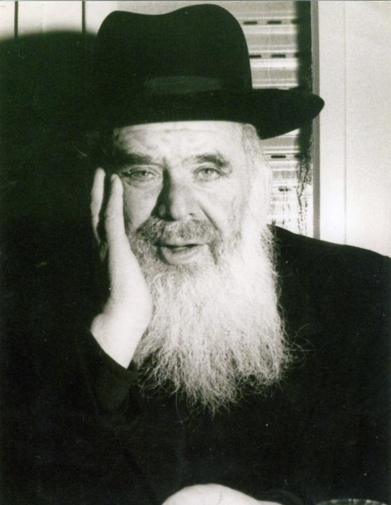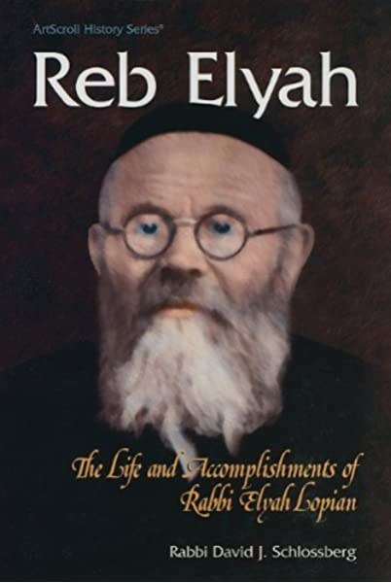
Rav Chaim Shmuelevitz and Rav Elya Lopian

A few short years after arriving in Eretz Yisroel and becoming a Maggid Shiur in the Mirrer Yeshivah, which had relocated from Shanghai, China, during WWII, Rav Chaim Shmuelevitz, zt”l, began experiencing considerable pain in his throat every time he spoke. At first, he dismissed it as simply a sore throat and refused to seek any sort of treatment, but when the pain became increasingly sharp and it began affecting his ability to deliver his Shiurim in Yeshivah, he decided to seek the advice of a doctor.

Treated by One of the Most
Knowledgeable Specialists in the Field
He was sent to one of the most knowledgeable specialists in the field who conducted a thorough examination, and even did a biopsy of the throat. When the results came back, the doctor informed Rav Chaim and his family that he was suffering from a malignant tumor in his throat, R”L.
Rav Chaim’s family took the news hard, and questioned the specialist about the effectiveness of potential options and treatments. The doctor, attempting to break the news easily, said, “I can operate to remove the cancerous growth from the Rav’s throat, and this will hopefully save his life. However, it is pretty certain that even if the surgery is a complete success, he will never be able to speak properly again. The tumor is in his voice box, and the entire organ would need to be removed to ensure the success of the operation.”
Rav Chaim listened to the doctor’s account and understood the ramifications. Still, he refused to give up hope. He went to speak with the great Mashgiach, Rav Elya Lopian, zt”l, to seek his guidance and advice. Rav Elya listened carefully as Rav Chaim gave over the words of the specialist.
“What should I do?” he asked urgently. He said, “Right now, I do experience great pain and difficulty when I speak, but I am still able to speak. If I do this surgery, the doctor believes that I will no longer have the ability to speak at all!”

You Have So Much Torah
And Mussar to Yet Give Over
Rav Elya responded without hesitation. “I cannot imagine that the Ribono Shel Olam would take away the ability of Rav Chaim Stutchiner (Rav Chaim came from the town of Stutchin and was known to many by his nickname Rav Chaim Stutchiner) to continue to say Shiurim to his Talmidim. There is still so much Torah and Mussar that you have yet to give over to this world. My opinion is that you do not do the operation.”
The words that came out of the Mashgiach’s mouth were said with such absolute and unequivocal certainty, that Rav Chaim accepted his decision on the spot. Rav Elya asked for Rav Chaim’s full name and his mother’s name, and promised that he would Daven for him to have a complete and speedy recovery. Rav Chaim returned to his normal routine and over time the pain in his throat lessened. He later went back to the specialist to inform him of his decision to forgo the surgery. As soon as Rav Chaim entered the doctor’s office, however, even before he had a chance to say one word to the doctor, the specialist decided to take another quick look into his throat to determine the urgency of the situation and how soon the life-saving operation must be performed.
What he found when he looked inside shocked him. Rav Chaim’s throat and voice box were absolutely clear! No trace of any disease could be found, and Rav Chaim said that his throat wasn’t even sore anymore!
Eight years later, when Rav Elya Lopian passed away, Rav Chaim Shmuelevitz was one of the people who delivered a eulogy. Rav Chaim cried bitter tears, and in his eulogy, he called out, “When I became deathly ill eight years ago, it was none other than Rav Elya who saved me and returned me to the land of the living. There is no doubt that it was due to him that I am here today. I wish to take this public opportunity to offer my most sincere and heartfelt appreciation to the great Tzadik Rav Elya Lopian!”

Reprinted from the Parshas Chayei Sarah 5781 email of Torah U’Tefilah as compiled by Rabbi Yehuda Winzelberg.

Scouted by the Major Leagues, Nevada Teen Won’t Play on Shabbat
By Faygie Levy Holt

Elie Kligman, a high school senior from Las Vegas who is one of the top-ranked players in Nevada and has been scouted by the Major Leagues, has never played on Shabbat, makes time to pray three times a day and keeps the Jewish dietary laws of kashrut.
For decades, Jewish baseball fans have looked to Sandy Koufax as a role model for refusing to pitch in game one of the 1965 World Series because it fell on Yom Kippur. While that stood out as an example for Jews everywhere, one Nevada teen is hoping to take it a step further and become the first Shabbat-observant, kosher-food-eating professional baseball player.
“My dream has always been to be a Major Leaguer. I never thought of anything else—baseball has always been what I’ve wanted to do,” says Elie Kligman, a high school senior from Las Vegas who plays as both an infielder and pitcher.

Has Been Playing Ball His Entire Life
The 18-year-old has been playing ball his entire life. After years of competing at all levels, Elie, who is on his high school team and one of the top-ranked players in Nevada, was one of only 175 high-schoolers from across the country—and the first Orthodox Jew—to take part in the Major League Baseball-scouted “Area Code Baseball Games.”

He does all this without compromising his Judaism. Elie has never played on Shabbat, makes time to pray three times a day and keeps the Jewish dietary laws of kashrut.
“I have the mindset of, ‘This is what I am doing for Judaism, and this is what I am doing for baseball.’ Once the sun goes down on Friday night, it’s not a debate for me, [celebrating Shabbat] is just what I am doing,” says the teen. “When you are a proud Jew, people respect when I tell them I’m not going to play on Friday night and Saturday.”

People are Interested in What He Eats and Does on Shabbat
In fact, he adds, people are actually interested in what he eats and what he does on Shabbat.
Elie was one of only 175 high-schoolers from across the country—and the first Orthodox Jew—to take part in the Major League Baseball-scouted “Area Code Baseball Games.”
Guiding him in his life and career has been his father, Marc Kligman, an attorney and professional sports agent who has coached Elie and younger brother Ari in the finer points of baseball over the years. He has also worked hard to provide his boys with opportunities to compete at a high level.

Wherever Elie and his family travel for a ball game, they make sure to visit the local Chabad House, where they can find kosher food or catch a prayer service.

“We’ve had a lot of help along the way,” he says. “People have been kind and helpful. Our head coach at the high school makes sure we don’t schedule any games on Saturday.”
But there have been plenty of times that the Kligman boys have had to sprint out of the house right after Shabbat ended to make a Saturday-night game, as well as “plenty of Shabbats alone in a hotel so we could be local” for a game, say their dad.
The Kligmans, including mom Laura and Elie’s twin sister, Tova, are members of Chabad of Summerlin, a suburb of Las Vegas. Their involvement with Chabad has made things easier over the years, as wherever they find themselves traveling to for a ball game, they make sure to visit the local Chabad House, where they can find kosher food or catch a prayer service.
“It’s a taste of home,” says Kligman. While Elie notes that other Chabad Houses have all been “awesome, especially the Chabad of Phoenix, we know a lot of the community because we go there a lot” for tournaments.

‘His Yiddishkeit Takes Precedence’
According to Rabbi Shea Harlig, director of Chabad of Southern Nevada, “It’s wonderful to watch Elie balance his commitment to a Torah-observant lifestyle and baseball at the same time, but when there is a conflict, his Yiddishkeit takes precedence.”

In fact, Elie and Ari both make time to study Torah, learning with Rabbi Chaim Ozer Metal, the youth director at Chabad of Summerlin, who says the family’s love of Judaism has even impacted others.
“Because of Elie and his family’s strong sense of Judaism, even when being out there playing baseball, they once encouraged a family to meet with me, which together resulted in the family putting mezuzot on their doors and enrolling their children in Hebrew school,” relates the rabbi.
For now, Elie is waiting to hear where he’ll be going to college, and if he will break new ground as the first Orthodox Jewish baseball player at a Division 1 school. (There have been several Orthodox teens who have played Division 1 basketball, starting with Maryland native Tamir Goodman in 2000.) If Elie does get recruited to a Division 1 school, then he’ll be among some of the country’s best college baseball players, moving him one step closer to his dream of playing in the Major Leagues.
One thing that won’t change, though, is his Judaism.
“People always ask me what I’m going to do in college,” says Elie. “The answer has always been I’m not playing on Shabbat. It’s for G-d, and I’m not changing that.”

Reprinted from the January 14, 2021 dispatch of Chabad.Org News.

